5/22/2026

Smarties Group Members
Siphelele Malotana
Nobahle Nzimande
Sipe Nonyukela
Liam Alexander

WEEK 1: Technical Support Fundamentals and Networking

Table of Contents

Task 1: Business Requirements Analysis 2
1. Company Overview & Organisational Structure 3
2. Business Requirements Summary 3
3. Business Application Requirements by Department 4
4. Operational Challenges 5
5. Data Security & Backup Requirements 6
6. Connectivity & Network Requirements 6
7. Key Recommendations 6
Task 2: Hardware Inventory 7
Hardware Inventory Table 7
Notes & Recommendations 9
Task 3: Software Inventory 9
Document Overview 10
1. Company-Wide Software 10
2. Department-Specific Software 10
3. Server and IT Infrastructure Software 12
4. Software Update Procedures 13
5. Estimated Monthly Software Licensing Cost Summary 14
Task 4: Initial Network Diagram 14
Task 5: Troubleshooting Scenarios 15
Scenario 1 — Desktop Not Powering On 16
Scenario 2 — No Internet Connectivity 17
Scenario 3 — Printer Offline 18

Task 1: Business Requirements Analysis

1. Company Overview & Organisational Structure
Ubuntu Innovations (Pty) Ltd is a rapidly growing technology startup based in Cape Town, South Africa. The company is relocating to a new office and requires a fully documented IT infrastructure built from scratch across its 25-person workforce.

Organisational Structure | Company Context
Department  Executive Management  Finance  Human Resources  Sales & Marketing  Software Development  TOTAL: 25 employees | Industry: Information Technology / Software Development  Stage: Early-growth startup  Location: Cape Town, Western Cape, South Africa  Office: New premises — greenfield IT deployment  IT Maturity: Low — no existing legacy infrastructure  Operating Hours: Mon–Fri, 08:00–17:00 SAST  Users: 25 full-time employees across 5 departments

2. Business Requirements Summary
The following requirements were identified across all departments and must be addressed through the IT infrastructure design, security policies, and support procedures.

# | Category | Requirement | Priority
1 | Connectivity | Wired & wireless LAN for all 25 users; business-grade firewall router | Critical
2 | User Management | Individual accounts with dept-based security groups & RBAC | Critical
3 | File Storage | NAS with departmental folder structure and access permissions | Critical
4 | Printing | Two shared network laser printers accessible across the LAN | Medium
5 | Data Security | Antivirus, device encryption (laptops), MFA, patch management | Critical
6 | Backup & Recovery | Daily incremental, weekly full, monthly archive; cloud offsite copy | High
7 | Applications | Microsoft 365 for all staff; dept-specific software per section 3 | Critical
8 | Power Protection | Two 1500VA UPS units protecting core networking equipment | High
9 | Documentation | Troubleshooting guide and IT support procedures for staff | Medium

3. Business Application Requirements by Department
Department | Required Software | Notes
All Staff (25) | Microsoft 365, Antivirus (Bitdefender), Zoom, Web Browser | Core productivity and security baseline for every device
Executive Mgmt (3) | Power BI, Asana, BitLocker encryption | Laptops must be fully encrypted; mobility-focused
Finance (4) | Sage Business Cloud, Advanced Excel, Seclore DRM | SARS-compliant; payroll data requires strict access control
Human Resources (3) | SimplePay, SharePoint (M365), DocuSign | Employee records need privacy controls and digital signing
Sales & Marketing (7) | HubSpot CRM, Canva Pro, Hootsuite, Google Analytics | Cloud-dependent; stable internet access is critical
Software Dev (8) | VS Code, Git, GitHub, Docker, Ubuntu Linux 22.04 | Developer workstations run Linux; elevated permissions needed

4. Operational Challenges
Six key operational challenges have been identified that the IT infrastructure design must be addressed from the outset.
Challenge | Description | Challenge | Description
Greenfield Deployment | All infrastructure must be built from scratch before operations begin. | Data Segregation | Finance and HR hold sensitive data requiring strict access controls.
Load Shedding | SA power outages risk downtime and data loss without UPS protection. | Cybersecurity Threats | Phishing and ransomware are high-probability risks requiring MFA and AV.
Scalability | Infrastructure must accommodate projected staff growth without a rebuild. | Software Licensing | 25 devices require tracked, compliant licenses across all applications.

5. Data Security & Backup Requirements
Data Security Controls | Backup & Recovery Schedule
Antivirus & endpoint protection on all 25 devices  BitLocker encryption on all 5 executive laptops  Multi-factor authentication (MFA) for all accounts  Security patching within 72hrs (critical) / 14 days (standard)  Written Acceptable Use Policy issued to all staff  Physical access controls for server room and network rack | Frequency Type Retention  Daily Incremental 7 days rolling  Weekly Full backup 4 weeks  Monthly Archive 12 months  Continuous Cloud offsite Real-time  RTO: < 4 hours | RPO: < 24 hours  NAS with RAID-5 as primary backup target

6. Connectivity & Network Requirements
Wired & Wireless Network | IP Addressing Plan (Preview)
Gigabit Ethernet for all 25 desktop workstations  24-port managed switch for internal LAN  2× Wi-Fi 6 dual-band access points for wireless coverage  Business-grade firewall router (NAT, VPN, traffic filtering)  VLAN segmentation: servers, users, printers, Wi-Fi  2× 1500VA UPS units for core equipment power protection | Device Type Subnet  Servers / NAS 192.168.10.0/24  User Devices 192.168.20.0/24  Printers 192.168.30.0/24  Wi-Fi Clients 192.168.40.0/24

7. Key Recommendations
# | Recommendation
1 | Deploy a VLAN-segmented network from day one to ensure security and scalability as the company grows.
2 | Implement centralized identity management (Active Directory or equivalent) for user accounts and group policy enforcement.
3 | Enforce a zero-trust security baseline from the outset: MFA on all accounts, endpoint AV, encrypted laptops, and a signed AUP.
4 | Select all hardware with a minimum 3-year South African vendor warranty to reduce support risk and downtime.
5 | Design the backup strategy to satisfy both on-premises (NAS/RAID-5) and offsite (cloud replication) requirements.
6 | Document all configurations, procedures, and troubleshooting guides immediately to reduce single-point-of-knowledge risk.
7 | Plan a 30% growth buffer in IP addressing, switch port capacity, and NAS storage to accommodate future hiring.

Task 2: Hardware Inventory

Hardware Inventory Table
The table below details all recommended hardware assets for Ubuntu Innovations (Pty) Ltd. All costs are estimated in South African Rand (ZAR).

Asset | Qty | Suggested Specification | Unit Cost | Total Cost | Business Justification | Warranty
Desktop Computers | 20 | Intel Core i5, 16GB RAM, 512GB SSD, Windows 11 Pro | R12,000 | R240,000 | General office use across all 5 departments | 3-year on-site warranty recommended
Laptops | 5 | Intel Core i7, 16GB RAM, 512GB SSD, Windows 11 Pro + BitLocker | R18,000 | R90,000 | Mobility for Executive Management team | 3-year on-site warranty recommended
Router / Firewall | 1 | Business-grade firewall router (e.g. Cisco RV340 / Fortinet 40F) | R8,500 | R8,500 | Secure internet access, NAT, VPN and traffic filtering | 3-year vendor support contract
Managed Switch | 1 | 24-port Gigabit managed switch (e.g. Cisco SG350-28) | R4,500 | R4,500 | Internal LAN for all 25 wired devices plus spare ports | 3-year vendor support contract
Wireless Access Points | 2 | Dual-band Wi-Fi 6 AP (e.g. Ubiquiti UniFi U6-LR) | R3,200 | R6,400 | Full wireless coverage across the office floor | 2-year manufacturer warranty
Network Printers | 2 | Monochrome laser printer with network card (e.g. HP LaserJet Pro M404dn) | R5,500 | R11,000 | Shared departmental printing - low cost per page | 1-year warranty; service contract optional
NAS Device | 1 | 8TB RAID-5 NAS (e.g. Synology DS423+ with 4x4TB WD Red drives) | R14,000 | R14,000 | Centralized file storage and daily backup target | 3-year manufacturer warranty
UPS Units | 2 | 1500VA UPS (e.g. APC Smart-UPS 1500VA LCD) | R3,800 | R7,600 | Power protection for network rack during load shedding | 2-year manufacturer warranty
TOTAL ESTIMATED BUDGET |  |  |  | R382,000

Notes & Recommendations
- All unit costs are estimates in South African Rand (ZAR) and may vary by supplier and market conditions at time of purchase.
- Desktop and laptop units must each include a valid Windows 11 Pro licence.
- The NAS device must be configured in RAID-5 to provide single-disk fault tolerance.
- UPS units protect the core network rack (router, switch, NAS) against South African load shedding.
- A hardware refresh cycle of 3-5 years is recommended for desktops and laptops.
- The 24-port switch provides spare ports to accommodate future staff additions.

Task 3: Software Inventory

Document Overview
This software inventory documents all recommended software for Ubuntu Innovations (Pty) Ltd, a 25-employee technology startup relocating to a new office in Cape Town. Software is organized by category: company-wide tools and department-specific applications. Licensing types, cost models, and deployment notes are included.

1. Company-Wide Software
The following software is required across all 25 users regardless of department.
Software | Purpose | Licence Type | Cost Model | Deployment
Ubuntu 22.04 LTS | Desktop operating system | Open Source (GPL) | Free | All desktops & laptops
LibreOffice 7.x | Word processing, spreadsheets, presentations | Open Source (MPL) | Free | All workstations
Google Workspace (Business Starter) | Email, Calendar, Drive, Docs, Meet | SaaS - Per user | R111/user/month (R2,775/month) | Web & desktop app
Bitwarden (Teams) | Password manager | SaaS - Per user | R55/user/month (R1,387/month) | Browser extension + app
ClamAV + Malwarebytes for Teams | Antivirus & endpoint protection | Open Source / Commercial | Free / R74/user/month | All endpoints
UFW (Uncomplicated Firewall) | Host-based firewall | Open Source | Free | All Linux machines
Timeshift | Local system snapshots | Open Source (GPL) | Free | All workstations
CUPS (Print Server) | Shared printer management | Open Source | Free | Server / all users
OpenVPN / WireGuard | Remote access VPN | Open Source | Free | Server + clients
Remmina | Remote desktop client | Open Source | Free | IT admin machines

2. Department-Specific Software

2.1 Executive Management (3 Users) — Strategic planning, communication, and reporting tools
Software | Purpose | Licence | Notes
Power BI / Google Looker Studio | Business dashboards & KPI reporting | Free / Paid | Looker Studio free; Power BI Pro R185/user
Slack (Pro) | Internal team messaging | SaaS - Per user | Optional; Google Chat already in Workspace
DocuSign / Xodo Sign | Electronic document signing | SaaS | R277/user/month
Trello / Asana (Free tier) | Project tracking | Freemium SaaS | Free for small teams

2.2 Finance Department (4 Users) — Accounting, payroll, and compliance software
Software | Purpose | Licence | Notes
Sage Business Cloud Accounting | Accounting & invoicing (SA-compliant) | SaaS - Per user | R350/user/month; VAT/SARS ready
Microsoft Excel (via M365 Basic) | Financial modelling & spreadsheets | SaaS - Per user | R111/user/month; alternative to LibreOffice
PaySpace / SimplePay | Payroll & HR (SA legislation compliance) | SaaS | PaySpace from ~R200/month
KeePassXC | Secure credential storage for finance systems | Open Source | Free

2.3 Human Resources (3 Users) — Employee management, onboarding, and leave tracking
Software | Purpose | Licence | Notes
BambooHR / Zoho People | HR management, leave & performance tracking | SaaS - Per user | Zoho from R20.61/user; BambooHR from R98.95/user
Google Forms | Employee surveys & onboarding forms | Included in Workspace | Free
Canva (Pro) | HR communications, onboarding materials | SaaS | R240/month/team
Zoom / Google Meet | Interview & HR meetings | Included in Workspace | Free

2.4 Sales and Marketing (7 Users) — CRM, campaign management, and content creation
Software | Purpose | Licence | Notes
HubSpot CRM (Free tier) | Customer relationship management | Freemium SaaS | Free up to 1M contacts; Paid from R832/month
Mailchimp / Brevo | Email marketing campaigns | Freemium SaaS | Free up to 500 contacts (Brevo)
Canva (Pro) | Marketing graphics & social media posts | SaaS | R240/month /team
Google Analytics | Website traffic analysis | Free (SaaS) | Free
Meta Business Suite / Buffer | Social media scheduling & management | Freemium SaaS | Buffer free for 3 channels

2.5 Software Development (8 Users) — Development environments, version control, collaboration
Software | Purpose | Licence | Notes
Visual Studio Code | Code editor / IDE | Open Source (MIT) | Free
Git + GitHub / GitLab | Version control & code repository | Open Source / SaaS | GitHub Free tier available
Docker Desktop (Linux) | Containerization & dev environments | Open Source (Apache 2) | Free on Linux
Postman | API testing & documentation | Freemium SaaS | Free tier available
VirtualBox | Local VM testing environments | Open Source (GPL) | Free
Jira / GitHub Issues | Sprint & issue tracking | Freemium SaaS | Free up to 10 users (Jira)
DBeaver Community | Database management & SQL editor | Open Source | Free

3. Server and IT Infrastructure Software
Software deployed on the company server and NAS to support network services.

Software | Purpose | Licence | Notes
Ubuntu Server 22.04 LTS | NAS / file server OS | Open Source | Free; LTS until 2027
Samba | Windows-compatible file sharing (SMB/CIFS) | Open Source (GPL) | Free
OpenLDAP | Centralised user directory services | Open Source | Free
Netdata / Zabbix | Network & server monitoring | Open Source | Free
Rsync + cron | Automated backup scripting | Open Source | Free
Veeam Agent for Linux (Free) | Backup and recovery | Freeware | Free for 1 server
Bind9 / dnsmasq | Internal DNS resolution | Open Source | Free
ISC DHCP Server | Dynamic IP assignment | Open Source | Free

4. Software Update Procedures

Update Type | Frequency | Method | Responsible
OS & package updates (Ubuntu) | Weekly (automated) + manual monthly review | apt update && apt upgrade or unattended upgrades | IT Administrator
Antivirus definitions | Daily (automated) | ClamAV freshclam daemon; Malwarebytes auto-update | IT Administrator
SaaS applications | Automatic (vendor-managed) | Browser / app auto-update | Vendors / IT to monitor
Open-source desktop apps | Monthly patch cycle | apt or Snap package manager | IT Administrator
Security patches (critical) | Within 48 hours of release | Emergency apt patch + restart where required | IT Administrator

5. Estimated Monthly Software Licensing Cost Summary

Category | Solution | Est. Monthly Cost (ZAR)
Productivity Suite | Google Workspace Business Starter (25 users) | R2,775
Password Manager | Bitwarden Teams (25 users) | R1,387
Antivirus (Endpoint) | Malwarebytes Teams (25 users) | R1,850
Electronic Signing | DocuSign / Xodo (3 exec users) | R832
Accounting | Sage Business Cloud (4 finance users) | R1,110
Payroll | SimplePay / PaySpace | R462
HR Management | Zoho People (3 HR users) | R74
CRM | HubSpot CRM Free | Free tier
Marketing | Canva Pro (team) | R240
Developer Tools | GitHub Free / Jira Free | Free tier
Open Source Tools | All other software listed above | Free tier
ESTIMATED TOTAL | * Open-source software constitutes the majority of the stack, significantly reducing licensing expenditure. | ~R7472 /month

* Costs are approximate ZAR estimates at ~R18.50/1USD. South African Rand equivalent will vary with exchange rates. All open-source software listed carries no licensing cost.

Task 4: Initial Network Diagram

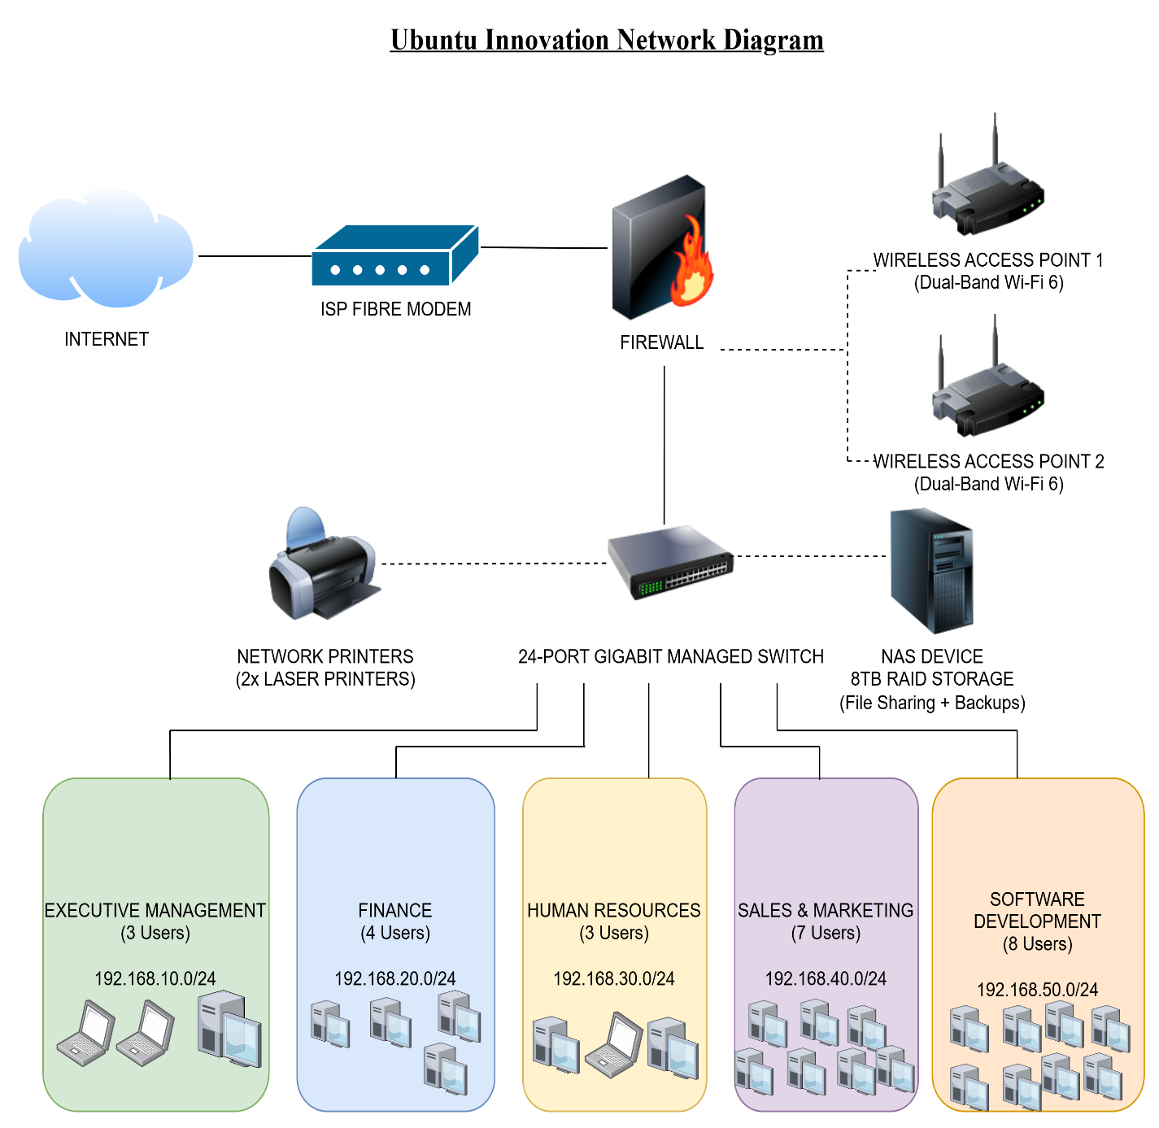

Task 5: Troubleshooting Scenarios

Scenario 1 — Desktop Not Powering On
Ticket Information
Issue Title: Desktop Computer Not Powering On
Priority: High
Category: Hardware Support
Reported By: End User
Status: Resolved
Problem Description
The user reported that the desktop computer would not power on after pressing the power button. The system showed no signs of activity and could not be used for work purposes.
Symptoms
- Power button not responding
- No lights displayed on the desktop
- No fan movement or startup sound
- Monitor remained blank
- Keyboard and mouse lights inactive
Possible Causes
- Faulty power cable
- Power supply unit (PSU) failure
- Loose internal power connections
- Damaged wall socket or power outlet
- Faulty motherboard or RAM issue
Troubleshooting Steps
- Verified that the wall socket was functioning correctly by testing another device.
- Checked the desktop power cable for visible damage and ensured it was securely connected.
- Confirmed that the power supply switch at the back of the desktop was turned on.
- Removed and reconnected the RAM modules to ensure proper seating.
- Opened the desktop case and checked for loose motherboard power connections.
- Tested the desktop using a different power cable and power outlet.
- Performed a power supply test using a spare PSU.
Resolution
The issue was caused by a faulty power supply unit. The PSU was replaced with a functioning unit, and the desktop powered on successfully afterward. The user confirmed that the system was operating normally.

Scenario 2 — No Internet Connectivity
Ticket Information
Issue Title: No Internet Connectivity on Workstation
Priority: Medium
Category: Network Support
Reported By: End User
Status: Resolved
Problem Description
The user reported being unable to access the internet on their workstation. Websites could not load, and online applications were unavailable.
Symptoms
- “No Internet Access” message displayed
- Browser pages failed to load
- Network icon showed limited connectivity
- Unable to ping external websites
- Email and cloud services inaccessible
Possible Causes
- Loose or disconnected network cable
- Router or modem failure
- Incorrect IP configuration
- Disabled network adapter
- ISP service interruption
Troubleshooting Steps
- Checked whether other devices could access the internet.
- Verified that the Ethernet cable was properly connected to the workstation and router.
- Restarted the router and modem.
- Disabled and re-enabled the network adapter.
- Ran Windows Network Troubleshooter.
- Opened Command Prompt and executed:
  - ipconfig /release
  - ipconfig /renew
  - ipconfig /flushdns
- Tested internet connectivity using the ping google.com command.
- Updated the network adapter drivers.
Resolution
The issue was caused by an incorrect IP address assignment. Renewing the IP configuration restored internet connectivity successfully. The user confirmed that all online services were functioning properly.

Scenario 3 — Printer Offline
Ticket Information
Issue Title: Network Printer Showing Offline
Priority: Medium
Category: Printer Support
Reported By: Office Staff
Status: Resolved
Problem Description
The office printer appeared offline, preventing users from printing documents from their computers.
Symptoms
- Printer status displayed as “Offline”
- Print jobs stuck in the print queue
- Unable to print test pages
- Printer not detected by workstation
- Error messages displayed during printing attempts
Possible Causes
- Printer disconnected from network
- Printer powered off
- Incorrect printer settings
- Print spooler service malfunction
- Outdated or corrupted printer drivers
Troubleshooting Steps
- Verified that the printer was powered on and connected to the network.
- Checked the printer display panel for error messages.
- Restarted both the printer and workstation.
- Cleared all stuck print jobs from the print queue.
- Restarted the Print Spooler service through Services Manager.
- Confirmed the printer was set as the default printer.
- Removed and reinstalled the printer drivers.
- Printed a test page to verify functionality.
Resolution
The issue was caused by a stuck print queue and an unresponsive Print Spooler service. Restarting the spooler service and clearing pending print jobs restored the printer to online status. Printing functionality was successfully restored.

